**Plasma citrulline concentration, a marker for intestinal functionality, reflects exercise intensity in healthy young men**

Shirley Kartaram¹, Marco Mensink6, Marc Teunis¹, Eric Schoen4, Gerrit Witte7, Lonneke Janssen Duijghuijsen6, Martie Verschuren2, Laura M’Rabet¹, Karen Knipping7, Harriet Wittink9, Ardy van Helvoort7,8, Johan Garssen3,7, Renger Witkamp6, Raymond Pieters¹,5  and Klaske van Norren6

*¹Research group Innovative Testing in Life Sciences and Chemistry, University of Applied Sciences Utrecht; 2Research group Analysis techniques in the Life Sciences, Avans University of Applied Sciences, Breda; 3Department of Pharmaceutical Sciences, Utrecht University, Utrecht, 4Netherlands Organization for Applied Scientific Research (TNO), Zeist; 5Institute for Risk Assessment Sciences, Immunotoxicology (IRAS), Utrecht University, Utrecht; 6Division Human Nutrition, Wageningen University & Research, Wageningen; 7Nutricia Research, Utrecht; 8School of Nutrition and Translational Research in Metabolism (NUTRIM), Maastricht University; 9Research group Lifestyle and Health, University of Applied Sciences Utrecht; The Netherlands*

**Keywords:** exercise intensity, citrulline, intestinal fatty acid binding protein, intestinal function

**Abstract**

**Background & aims**

The ability to produce citrulline from a glutamine bolus is a marker for enterocyte metabolic mass which is reduced in case of intestinal dysfunction. In this study, we investigated the effects of exercise-intensity on citrulline and intestinal Fatty Acid Binding Protein (iFABP) levels applying protocols differing in exercise load and hydration state.

**Methods**

Fifteen healthy young men (20-35 yrs, VO2 max 56.9 ± 3.9 ml kg-1min-1) performed in a partial randomly assigned cross-over design, a rest (protocol 1) and four cycle ergometer protocols. The volunteers cycled submaximal at different percentages of their individual pre-assessed maximum workload (Wmax): 70% Wmax in hydrated (protocol 2) and dehydrated state (protocol 3), 50% Wmax (protocol 4) and intermittent 85/55% Wmax in blocks of 2 min (protocol 5). Immediately after 1 hour exercise or rest, subjects were supplemented with a glutamine bolus with added alanine as an iso-caloric internal standard (7.5 g of each amino acid). Blood samples were collected before, during and after rest or exercise, up to 24h post onset of the experiment. Amino acids and urea were analyzed as metabolic markers and iFABP as a marker of intestinal damage. Data were analyzed using a multilevel mixed linear statistical model. P values were corrected for multiple testing.

**Results**

Citrulline levels already increased before glutamine supplementation during normal hydrated exercise, while this was not observed in the dehydrated and rest protocols. The low intensity exercise protocol (50% Wmax) showed the highest increase in citrulline levels both during exercise (43.83 µmol/L ± 2.63 (p < 0.001)) and after glutamine consumption (50.54 µmol/L ± 2.62) compared to the rest protocol (28.97 µmol/L ± 1.503 and 41.65 µmol/L ± 1.96, respectively, p<0.05). However, following strenuous exercise at 70% Wmax in the dehydrated state, citrulline levels did not increase during exercise and less after the glutamine consumption when compared to the resting condition and hydrated protocols. In line with this, serum iFABP levels, were the highest with the strenuous dehydrated protocol (1443.72 µmol/L ± 249.9, p < 0.001), followed by the high intensity exercise at 70% Wmax in the hydrated condition.

**Conclusions**

Exercise itself already can induce an increase in plasma citrulline. The extent to which this occurs is dependent on exercise intensity and the hydration state of the subjects. The same holds true for the post-exercise increase in citrulline levels following glutamine supplementation. iFABP levels are highest during strenuous exercise whereas low intensity exercise at 50% Wmax does not show an increase of iFABP levels. To our knowledge this is the first time that exercise workload-related effects on plasma citrulline levels are reported.

This study is registered at isrctn.com with code ISRCTN13656034.

**Introduction**

Citrulline is a non-protein amino acid which is almost exclusively synthesized by the proximal small intestine from its main precursor glutamine [1]. Studies have shown that a decrease of citrulline formation is proportional to the loss of functional enterocyte metabolic capacity during intestinal diseases or other factors affecting the GI tract [1,2]

Recently, we reported that in well-trained men, plasma citrulline levels following a glutamine-containing casein oral bolus were lower after strenuous glycogen-depleted and prolonged endurance exercise compared to the resting condition [3,4]. In addition, we previously showed that high intensity exercise consisting of 1 hour cycling at 70% of the maximal workload (Wmax) increases serum intestinal Fatty Acid-Binding Protein (iFABP) in recreationally trained men [5]. iFABP is a soluble cytosolic protein present within enterocytes which can be measured in blood after injury or inflammation of the small intestine [6,7]. These previous data suggest an exercise-induced decrease of intestinal metabolism and confirms earlier findings of exercise-induced intestinal permeability [8–10]. Based on these findings we hypothesized that different intensities of exercise and hydration state is related to the effects of exercise on intestinal function as a consequence of splanchnic hypoperfusion. During (sub) maximal physical exercise, splanchnic hypoperfusion is induced in healthy young volunteers [11]. Organ blood flow and oxygen delivery are less impaired by low intensity exercise compared to high intensity or strenuous exercise in dehydrated condition.

The present study was conducted to determine the relationship between exercise-induced citrulline formation and release of iFABP. To this end, we performed human exercise studies with healthy volunteers on a bicycle ergometer and measured post-exercise citrulline production and serum iFABP levels in volunteers performing various exercise intensities.

**Subjects and Methods**

The current study was approved by the medical ethics committee of Wageningen University Research Centre (WUR), The Netherlands, ISRCTN code 13656034, and was conducted according the Declaration of Helsinki (Fortaleza, Brazil, 2013).

**Subjects**

Fifteen healthy recreational-active male cyclists were selected for this study. They were recruited by means of flyers distributed at the campus of Wageningen University and regional cycling clubs, by word of mouth and via social media. Exclusion criteria were smoking, records of allergies, gastro-intestinal and immune diseases, use of hard drugs and participation in other clinical studies. The subjects were instructed not to perform intense physical activity and not to consume alcohol, two days prior to the test days. To standardize food-intake during the test period, dinners were provided for the evenings before the test days and at test days themselves. In addition, subjects were requested to keep a diary with training and dietary and illness logs during the whole study period. Subjects characteristics are presented in **Table 1.**

**Preliminary testing**

Based on a health questionnaire, subjects were selected for an incremental exercise test. The maximal workload (Wmax) was determined using an electronically braked cycle ergometer (Lode Excalibur, Groningen, The Netherlands). After a short warming-up, the subjects started cycling at 100W with a pedal frequency of 90-100 rotations per minute (RPM). The power increased every minute with 20W until the subject was not able to maintain the workload and felled back in pedal frequency to less than 70 RPM.

**Study design**

In this study with a partial cross-over design, all subjects started with protocol 1, the rest protocol without exercise (), followed by 4 randomly assigned 1 hour cycling protocols with different intensity and hydration status: 70% Wmax hydrated (protocol 2) and dehydrated (protocol 3), 50% Wmax (protocol 4) and intermittent 85/55% Wmax in blocks of 2 min (protocol 5). To standardize the hydration intervention, the 70% Wmax hydrated and dehydrated protocols were assigned as one block and performed consecutively. To attain a dehydrated condition, subjects were asked to restrict their intake of water to 0.5L the day before the test day. The wash-out-period between the experimental protocols was one week.

**Figure 1** shows a schematic overview of the study design. An overview of the experimental protocols is shown in **Table 2.**

**Test schedule and blood sampling**

In the morning, subjects arrived at the laboratory after an overnight fast. Their body weight was measured to control for weight loss and hydration status during exercise. To enable multiple venous blood collection, a cannula (Venflon Pro Safety, Becton Dickinson) was inserted in an antecubital vein. Before obtaining a baseline sample in fasted condition, subjects were asked to sit and relax for 10-15 min. After a light breakfast (2 wholemeal crackers with peanut butter and a cup of tea) subjects started, aside from the rest condition as first experimental protocol, with one of the assigned cycling protocols.

Directly after 1h of testing (rest or cycling) body weight was measured to determine post-exercise rehydration corresponding to 150% of body mass loss during exercise. During the remainder of the test day subjects consumed 200mL of tap water every hour. Peters et al. [12] studied citrulline plasma levels in time after a dipeptide glutamine-alanine bolus. In our study the volunteers ingested 125mL tap water with a 7.5g glutamine (Adamin G, Nutricia/SHS International Ltd) bolus to which 7.5g of alanine (L-Alanine, Nutricia/SHS International Ltd, England) was added as an iso-caloric internal standard. Blood samples were collected during (0.5h), at the end (1h), and at several time points after cycling (1.5h, 2h, 3h, 6h, 24h) in EDTA plasma tubes as well as in serum separator tubes for analyses of amino acids and iFABP, urea and cortisol, respectively. Subjects arrived the next morning again fasted at the laboratory for a blood collection of 24h to analyze recovery. **Figure 2** gives an overview of the blood sampling during an experimental protocol.

**Plasma and serum analysis**

Plasma levels of citrulline, glutamine and alanine were analyzed by ultrafast liquid chromatography (UFLC) (Shimadzu) using a pre-column derivatization with o-phtaldialdehyde and fluorimetric detection [13].

For evaluation of exercise-induced small intestinal damage, serum iFABP levels were measured with a commercial human ELISA Test Kit (HK406, Hycult Biotech, Uden, The Netherlands) and analysed with a multi-detector microplate reader VICTOR™ X3 (PerkinElmer) using Workout v2.5 software. Cortisol and urea serum levels were measured with a Cobas (Roche) of the Lab Automation system of the Foundation of general practitioner’s laboratory according to standard procedures (SHL, Etten Leur, The Netherlands).

**Statistical analysis**

Data were analysed using a multilevel mixed linear model. The model included terms that capture the random variation between the subjects, between the five experimental protocols per subject and within these experimental protocols. The analysis models the effects of overall protocol differences, differences between the time points within a protocol and the protocol by time interaction. The latter models the differences among the protocols of the respective time profiles. The analyses were performed using the statistical software GenStat (version 18) and R [14] packages lme4 [15] and nIme [16]. Prior to analysis, the data were log transformed to ensure compatibility with the assumption of a constant standard deviation of the observations. Data are presented as mean ± SD. To focus on statistically significant effects, we corrected the raw P values for multiple testing [17]. Outcomes of statistical tests with P < 0.05 were considered statistically significant.

**Results**

Fourteen out of the fifteen volunteers completed all protocols. Due to personal and practical issues one volunteer did not completed the high intensity exercise protocol in dehydrated condition. The rest of the data for this volunteer was included in the analysis.

The glutamine-alanine bolus was administered immediately after one hour of exercise or rest. Therefore, the amino acid plasma levels of 0<T≤1h represent pre-prandial levels during exercise, and plasma levels > T1h, represent post-prandial levels after exercise.

**Pre-prandial plasma concentrations alanine, glutamine, citrulline and arginine during exercise**

Plasma levels of glutamine, alanine, citrulline and arginine were determined at the time points indicated in **Figure 3A-D.** Already before administration of the glutamine-alanine bolus, levels of alanine and citrulline, but not of glutamine and arginine, changed significantly during some of the exercise protocols.

Alanine levels were almost doubled (from around 350µmol/L to over 600µmol/L (p < 0.001)) at 30 min of exercise in both hydrated and dehydrated 70% Wmax and the intermittent activity protocols and remained at the same increased level during the exercise. Increase was less (to around 500 µmol/L) in the low intensity exercise protocol (50% Wmax) and remained at background level during resting condition.

Plasma levels of citrulline were increased in all exercise protocols in hydrated condition (50%, 70% and 55/85% Wmax, (p<0.001, **Figure 3C**)). Citrulline levels gradually increased from around 35 µmol/L at start of the exercise to 38-40 µmol/L at 30 min and to 40-45 µmol/L at 60 min of the exercise. Citrulline levels remained at background level or even decreased during the rest and the dehydrated 70% Wmax protocols. Plasma arginine levels increased in all the experimental protocols during exercise. However, the increase in plasma citrulline and arginine levels were most pronounced with the low intensity exercise protocol of 50% Wmax, respectively 45 µmol/L (p<0.001) and 130 µmol/L (p < 0.05, **(Figure 3C and D).** The smallest rise in arginine levels (p < 0.01) appeared in the high intensity protocol of 70% Wmax in dehydrated condition.

During exercise the pre-prandial levels of glutamine were not significantly different between the conditions (p ≥ 0.05).

**Exercise-induced post-prandial plasma concentrations alanine, glutamine, citrulline and arginine**

After 1h exercise or rest, all the subjects ingested a glutamine-alanine bolus of 7.5g of each amino acid. Plasma alanine (**Figure 3B)** and glutamine (**Figure 3A)** levels increased rapidly to peak concentrations 0.5 h post-prandially (1000-1250 µmol/L and 875-975 µmol/L respectively), except with the strenuous exercise at 70% Wmax in dehydrated condition**.** In the dehydrated condition the time to peak was delayed half an hour when compared to the protocols in hydrated condition, with lower plasma concentrations of alanine and glutamine (900 µmol/L and 875 µmol/L respectively (p < 0.001)). After the ingestion of the glutamine bolus, citrulline levels increased in all protocols and reached a maximum at 1hour post-exercise (**Figure 3C)**. This post-prandial increase was, as for the response during exercise, the highest for the mild 50% Wmax exercise protocol (50 µmol/L). The strenuous 70% Wmax exercise protocol in dehydrated condition showed the smallest increase**.**

Post-prandial plasma arginine (**Figure 3D)** levels decreased in time from the post-exercise peak in all exercise protocols in hydrated condition. In dehydrated condition the plasma arginine concentrations still increased slowly post-exercise to peak 1h post-prandial (115 µmol/L).

**Urea levels**

Urea is an end-product metabolite of amino acids breakdown. During the rest condition, pre-prandial urea serum levels remained constant (**Figure 3E**), in contrast to a rise in all exercise protocols. After the intake of the glutamine bolus, post-prandial levels increased in all experimental protocols, with the biggest increase in the high intensity 70% Wmax exercise protocol in dehydrated condition (p < 0.05).

**Serum iFABP and cortisol levels**

To measure exercise-induced intestinal damage of the small intestine, serum levels of iFABP were evaluated [6,7]. Serum cortisol levels were analysed to measure the extent of stress. The high intensity exercise protocols (70% Wmax (de)hydrated and 55/85% Wmax) produced an increase in serum iFABP levels directly at the start of exercise (**Figure 4A)**. The 70% Wmax dehydrated protocol appeared to result in the biggest rise at the end of exercise (1750pg/mL (p< 0.001)). In line with iFABP levels, cortisol levels also increased in the high intensity exercise protocols (p < 0.001), **Figure 4B**). The low intensity exercise 50% Wmax protocol however, showed decreased levels as also seen in rest condition in both iFABP and cortisol serum concentrations. At the end of exercise, iFABP levels with the high intensity protocols decreased, returning to levels comparable to those of the low intensity protocol 2h post-exercise. Cortisol levels returned to levels of the rest condition and low intensity exercise 24h post-exercise.

**Discussion**

To our knowledge, this is the first study that reports the relationship between exercise intensity and the plasma levels of citrulline released during the type of exercise described here. iFABP, known as biomarker of intestinal function and damage, showed an inverse effect, increasing with higher exercise stress load [3,18,19]. Our data confirm and build on our previous observations in a strenuous exercise model with a glycogen depleted condition in which we observed an almost complete reduction of the increase in post-prandial plasma citrulline [3]. Importantly, in the current study, the most exhausting exercise (70% Wmax in dehydrated condition) caused a reduction of the pre-prandial levels of citrulline while inducing the highest levels of iFABP within the same time frame. During exercise, levels of alanine increased although no alanine had been administered yet at that time. The increase is probably through the action of alanine aminotransferase which converts glutamate to alanine in the glucose-alanine cycle, as a mechanism of mobilisation from the muscles. An additional important finding is that at low intensity exercise (50% Wmax), citrulline and alanine levels increased whereas levels of iFABP remained at background level.

Our data are well in line with the concept that exercise can induce a temporal situation of intestinal dysfunction, due to ischemic hypoperfusion, depending upon the exercise conditions and the exercise intensity [20]. It also indicates that both plasma citrulline and serum iFABP levels are indicative for the severity of exercise-induced intestinal stress, with the 70% Wmax protocol in a dehydrated condition inducing the most pronounced effects. These results support findings of van Wijck et al. [18] which are showing increased iFABP levels during high intensity exercise (1h cycling at 70% Wmax). At the end of exercise, after glutamine supplementation, iFABP levels decreased rapidly. It is known that glutamine serves as energy source for enterocytes and is used to restore intestinal functioning in clinical settings [21–23]. However, from our experimental set-up we cannot conclude whether the decrease of iFABP is due to either glutamine administration or citrulline formation, to both, or reflects normal decrease in time after exercise.

Levels of cortisol, a marker for metabolic stress, showed a decrease during the rest condition, which likely reflects a normal circadian pattern of the participant [24]. It is interesting that the mild intensity protocol of 50% Wmax showed the same decrease in cortisol during the day, as it indicates that indeed the 50% protocol can be considered as mild. Notably, lower cortisol levels indicating less myocellular damage and stress for swimming than running, are also shown by Casuso et al.[11] In contrast, the high intensity (70% Wmax (both hydrated and dehydrated) and 55/85% Wmax) exercises induced a comparable increase in cortisol levels. The similarity with the pattern of changes in iFABP levels indicates that intestinal changes marked by iFABP depend on remarkable physical stress, unlike citrulline and alanine levels that also increased at the mild exercise and low stress.

Post-prandial, post-exercise levels of alanine and glutamine showed a comparable increase in all hydrated conditions, suggesting that uptake of these amino acids is not affected in these situations. However, in the dehydrated high-intensity condition the uptake appeared to be impaired. This is in line with earlier findings that a decrease in body fluid changes metabolic function and physical performance [25–27].

There are some indications that citrulline might have a role in muscle function, increasing exercise capacity and reducing fatigue [28]. Suzuki et al. [29] have shown that L-citrulline supplementation enhances cycling time trial performance, while Le Plénier et al. [30] reported citrulline to be an activator of the mTOR pathway involved in muscle protein synthesis through phosphorylation of p70 ribosomal protein S6 kinase 1 (S6K1) and 4E-binding protein 1 (4E-BP).

It is also suggested that citrulline acts as precursor for arginine, which might help to maintain blood flow to the muscle, by contributing to e-NOS induced NO production [29,31]. Our data show that post-rest or post-exercise increased citrulline levels following glutamine supplementation were not correlated with increased arginine levels in any exercise protocol nor during the rest condition. The effect might however be local at muscle level and therefore not measurable in the blood. During exercise arginine levels increased in each protocol. The increase during strenuous exercise (70% Wmax in dehydrated condition) continued 1h post-exercise. This might be due to more oxidative stress and therefore a greater demand of blood flow as a consequence of the dehydration.

An interesting hypothesis is that plasma citrulline, produced from glutamine in the small intestine, plays a role in modulating muscle fatigue or as a signaling molecule to prevent exercise overload [29]. This may be a physiological protective mechanism for endurance training.

**Conclusion**

To our knowledge, this is the first time that in one and the same experimental design effects of different exercise protocols on plasma citrulline levels were evaluated in relation to intestinal metabolic capacity and integrity. We showed that during exercise, as well as following a glutamine bolus after exercise, the increase of plasma citrulline levels was dependent on exercise-intensity and hydration state. Moreover, effects on citrulline levels coincide with inversed levels of iFABP and cortisol. Our findings contribute to a better understanding of intestinal physiology and adaptations taking place during (strenuous) exercise. Furthermore, the combination of biomarkers and test protocols can be used to evaluate potential interventions directed at impaired intestinal functionality resulting from stress or disease.

**Acknowledgements**

We would like to thank all subjects for their commitment during the study. Furthermore, we would like to thank Susanne Muckenschnabel, Anne Geijssen, Annelies Laan, Vera Peters, Sven de Leeuw and Lenny Gribnau for their efforts and dedication as trainees during the study period. Our gratitude is expressed to Henriette Fick-Brinkhof, Anita Bruggink-Hoopman, Jantien Takens, Lucy Ockma and Diana Emmen-Benink for their support in sample collection.

**Conflict-of-interest**

The authors declare that they have no conflict of interest.

This study has been funded by The Dutch Society of Sciences and Art NWO SIA, RAAK project RAAK PRO 4-017

# **References**

[1] Crenn P, Messing B, Cynober L. Citrulline as a biomarker of intestinal failure due to enterocyte mass reduction. Clin Nutr 2008;27:328–39. doi:10.1016/j.clnu.2008.02.005.

[2] Jianfeng G, Weiming Z, Ning L, Fangnan L, Li T, Nan L, et al. Serum citrulline is a simple quantitative marker for small intestinal enterocytes mass and absorption function in short bowel patients. J Surg Res 2005;127:177–82. doi:10.1016/j.jss.2005.04.004.

[3] JanssenDuijghuijsen LM, Mensink M, Lenaerts K, Fiedorowicz E, van Dartel DAM, Mes JJ, et al. The effect of endurance exercise on intestinal integrity in well-trained healthy men. Physiol Rep 2016;4. doi:10.14814/phy2.12994.

[4] JanssenDuijghuijsen LM, Keijer J, Mensink M, Lenaerts K, Ridder L, Nierkens S, et al. Adaptation of exercise-induced stress in well-trained healthy young men. Exp Physiol 2016. doi:10.1113/EP086025.

[5] JanssenDuijghuijsen LM, van Norren K, Grefte S, Koppelman SJ, Lenaerts K, Keijer J, et al. Endurance Exercise Increases Intestinal Uptake of the Peanut Allergen Ara h 6 after Peanut Consumption in Humans. Nutrients 2017;9. doi:10.3390/nu9010084.

[6] Timmermans K, Sir Ö, Kox M, Vaneker M, de Jong C, Gerretsen J, et al. Circulating iFABP Levels as a marker of intestinal damage in trauma patients. Shock 2015;43:117–20. doi:10.1097/SHK.0000000000000284.

[7] Schellekens DHSM, Grootjans J, Dello SAWG, van Bijnen AA, van Dam RM, Dejong CHC, et al. Plasma intestinal fatty acid-binding protein levels correlate with morphologic epithelial intestinal damage in a human translational ischemia-reperfusion model. J Clin Gastroenterol 2014;48:253–60. doi:10.1097/MCG.0b013e3182a87e3e.

[8] van Wijck K, Lenaerts K, van Loon LJC, Peters WHM, Buurman WA, Dejong CHC. Exercise-induced splanchnic hypoperfusion results in gut dysfunction in healthy men. PLoS One 2011;6:e22366.

[9] Pals KL, Chang R-T, Ryan AJ, Gisolfi C V. Effect of running intensity on intestinal permeability. J Appl Physiol 1997;82:571–6.

[10] Marchbank T, Davison G, Oakes JR, Ghatei MA, Patterson M, Moyer MP, et al. The nutriceutical bovine colostrum truncates the increase in gut permeability caused by heavy exercise in athletes. Am J Physiol Gastrointest Liver Physiol 2011;300:G477-84. doi:10.1152/ajpgi.00281.2010.

[11] Casuso R, Aragon-Vela J, Huertas J, Ruiz-Ariza A, Martínez-Lopez E. Comparison of the inflammatory and stress response between sprint interval swimming and running. Scand J Med Sci Sports 2017:0–2. doi:10.1111/sms.13046.

[12] Peters JHC, Wierdsma NJ, Teerlink T, van Leeuwen PAM, Mulder CJJ, van Bodegraven AA. The citrulline generation test: proposal for a new enterocyte function test. Aliment Pharmacol Ther 2008;27:1300–10. doi:10.1111/j.1365-2036.2008.03678.x.

[13] Teerlink T, Van Leeuwen PAM, Houdijk A. Plasma amino acids determined by liquid chromatography within 17 minutes. Clin Chem 1994;40:245–9.

[14] Team RC. The R Project for Statistical Computing. Http://WwwR-ProjectOrg/ 2013:1–12. doi:10.1159/000323281.

[15] Bates D, Mächler M, Bolker B, Walker S. Fitting Linear Mixed-Effects Models Using **lme4**. J Stat Softw 2015;67:1–48. doi:10.18637/jss.v067.i01.

[16] Pinheiro J, Bates D, DebRoy S, Sarkar D, EISPACK authors, Heisterkamp S. Linear and Nonlinear Mixed Effects Models [R package nlme version 3.1-131] n.d. https://cran.r-project.org/web/packages/nlme/index.html (accessed January 25, 2018).

[17] Benjamini Y, Hochberg Y. Benjamini Y, Hochberg Y. Controlling the false discovery rate: a practical and powerful approach to multiple testing. J R Stat Soc B 1995;57:289–300. doi:10.2307/2346101.

[18] van Wijck K, Lenaerts K, van Loon LJC, Peters WHM, Buurman WA, Dejong CHC. Exercise-induced splanchnic hypoperfusion results in gut dysfunction in healthy men. PLoS One 2011;6:e22366. doi:10.1371/journal.pone.0022366.

[19] Van Wijck K, Wijnands KAP, Meesters DM, Boonen B, Van Loon LJC, Buurman WA, et al. L-citrulline improves splanchnic perfusion and reduces gut injury during exercise. Med Sci Sports Exerc 2014;46:2039–46. doi:10.1249/MSS.0000000000000332.

[20] van Wijck K, Lenaerts K, Grootjans J, Wijnands KAP, Poeze M, van Loon LJC, et al. Physiology and pathophysiology of splanchnic hypoperfusion and intestinal injury during exercise: strategies for evaluation and prevention. Am J Physiol Gastrointest Liver Physiol 2012;303:G155-68. doi:10.1152/ajpgi.00066.2012.

[21] Leite RD, Lima NL, Leite CAC, Farhat CK, Guerrant RL, Lima AAM. Improvement of intestinal permeability with alanyl-glutamine in HIV patients: a randomized, double blinded, placebo-controlled clinical trial. Arq Gastroenterol 2013;50:56–63. doi:10.1590/S0004-28032013000100011.

[22] Butjs N, Brinkmann SJH, Oosterink JE, Luttikhold J, Schierbeek H, Wisselink W, et al. Intravenous glutamine supplementation enhances renal de nova arginine synthesis in humans: a stable isotope study. Am J Clin Nutr 2014;100:1385–91. doi:10.3945/ajcn.113.081547.

[23] Luttikhold J, Oosting A, van den Braak CCM, van Norren K, Rijna H, van Leeuwen PAM, et al. Preservation of the gut by preoperative carbohydrate loading improves postoperative food intake. Clin Nutr 2013;32:556–61. doi:10.1016/j.clnu.2012.11.004.

[24] Aloui K, Abedelmalek S, Chtourou H, Wong D, Boussetta N, Souissi N. Effects of time-of-day on oxidative stress, cardiovascular parameters, biochemical markers, and hormonal response following level-1 Yo-Yo intermittent recovery test. Physiol Int 2017;104:77–90. doi:10.1556/2060.104.2017.1.6.

[25] Costa RJS, Snipe R, Camões-Costa V, Scheer V, Murray A. The Impact of Gastrointestinal Symptoms and Dermatological Injuries on Nutritional Intake and Hydration Status During Ultramarathon Events. Sport Med - Open 2016;2:16. doi:10.1186/s40798-015-0041-9.

[26] Ebert TR, Martin DT, Bullock N, Mujika I, Quod MJ, Farthing LA, et al. Influence of hydration status on thermoregulation and cycling hill climbing. Med Sci Sports Exerc 2007;39:323–9. doi:10.1249/01.mss.0000247000.86847.de.

[27] Cheuvront SN, Carter R, Sawka MN. Fluid balance and endurance exercise performance. Curr Sports Med Rep 2003;2:202–8.

[28] Takeda K, Machida M, Kohara A, Omi N, Takemasa T. Effects of citrulline supplementation on fatigue and exercise performance in mice. J Nutr Sci Vitaminol (Tokyo) 2011;57:246–50.

[29] Suzuki T, Morita M, Kobayashi Y, Kamimura A. Oral L-citrulline supplementation enhances cycling time trial performance in healthy trained men: Double-blind randomized placebo-controlled 2-way crossover study. J Int Soc Sports Nutr 2016;13:6. doi:10.1186/s12970-016-0117-z.

[30] Le Plénier S, Goron A, Sotiropoulos A, Archambault E, Guihenneuc C, Walrand S, et al. Citrulline directly modulates muscle protein synthesis via the PI3K/MAPK/4E-BP1 pathway in a malnourished state: evidence from in vivo, ex vivo, and in vitro studies. Am J Physiol Endocrinol Metab 2017;312:E27–36. doi:10.1152/ajpendo.00203.2016.

[31] Kim I, Schutzler SE, Schrader A, Spencer HJ, Azhar G, Deutz NEP, et al. Acute ingestion of citrulline stimulates nitric oxide synthesis but does not increase blood flow in healthy young and older adults with heart failure 2015:915–24. doi:10.1152/ajpendo.00339.2015.

**Tables and Figures**

**Table 1.** Characteristics and performance data of all subjects.

Data are shown as mean with SD.

|  |  |
| --- | --- |
| Age (yrs) | 24,3 ± 2.4 |
| BMI (kg/m2) | 22,5 ± 1,5 |
| Weight (kg) | 75.8 ± 6.7 |
| Length (cm) | 183.4 ± 3.8 |
| VO2max (ml/kg/min) | 56.9 ± 3.9 |
| Wmax (W) | 335,1 ± 39.9 |

**Table 2.** Experimental protocols with exercise intensity and hydration status

|  |  |
| --- | --- |
| **Protocol** | **Exercise intensity and hydration status** |
| 1: rest condition | no exercise |
| 2: high intensity exercise | 1 hour cycling 70% Wmax, hydrated |
| 3: strenuous exercise | 1 hour cycling 70% Wmax, dehydrated |
| 4: low intensity exercise | 1 hour cycling 50% Wmax, hydrated |
| 5: high intensity interval exercise | 1 hour cycling 55/85% Wmax, hydrated |

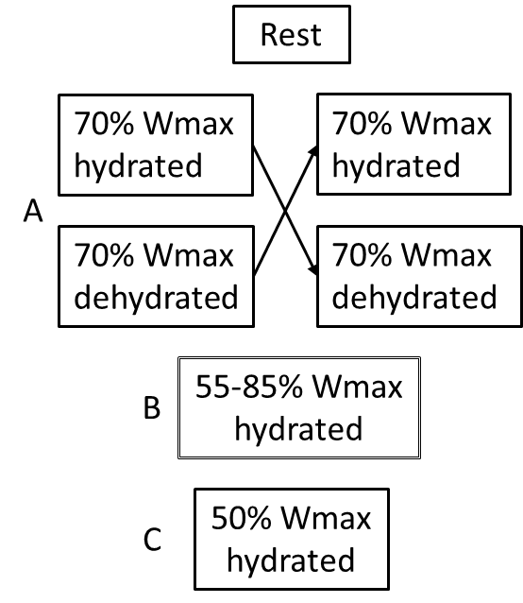**Figure 1.** Following 1 week of rest, each subject underwent 4 different exercise load interventions which were partial randomly assigned (blocks A, B, and C). The 70 % Wmax interventions in hydrated and dehydrated condition (block A) were conducted in sequence. The wash-out-period between the protocols was 1 week.

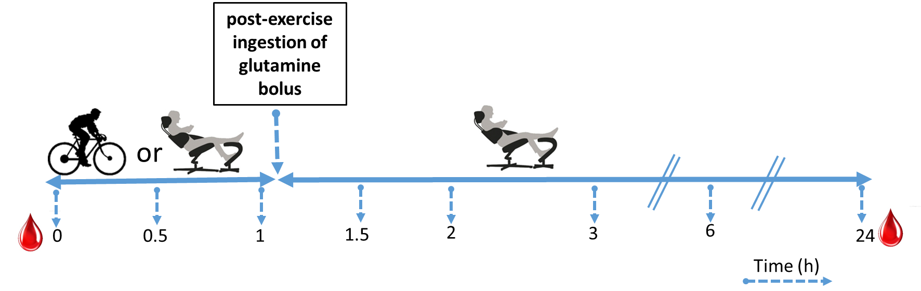

**Figure 2.** Schematic overview of bloodsampling during an experimental protocol.

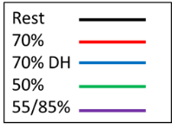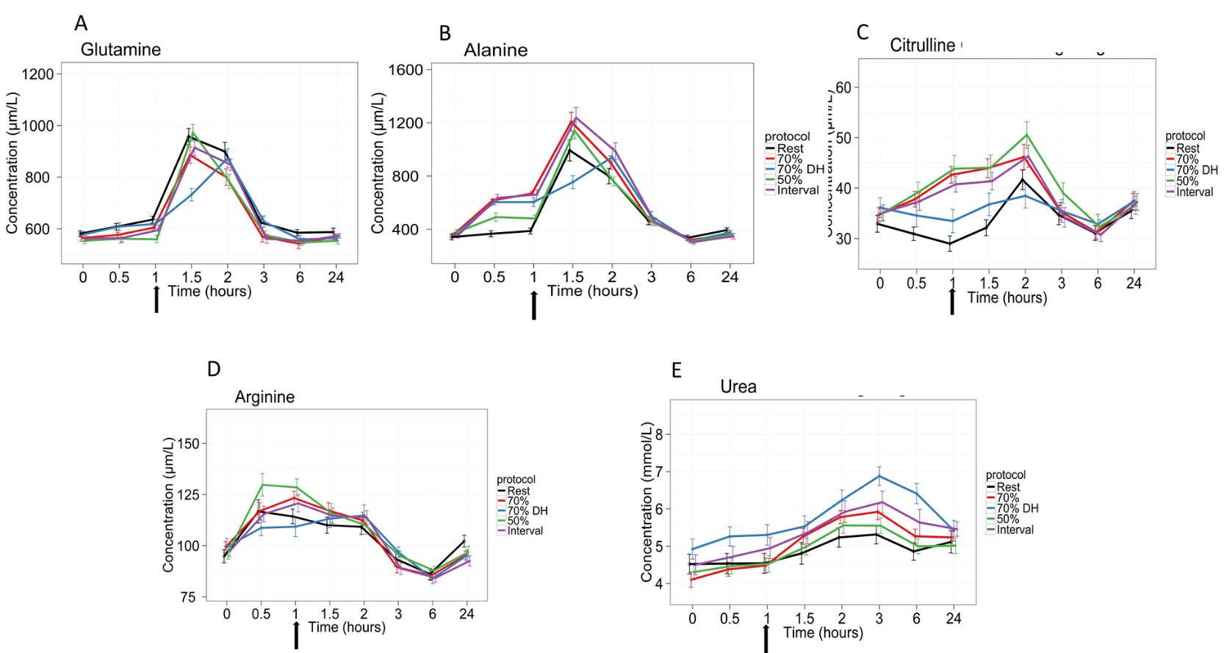

**Figure 3**. Effects of the experimental protocols on levels of plasma glutamine (A), alanine (B), citrulline (C), arginine (D) and urea (E). The black line represents the rest condition, the red and blue lines are showing the effects of 70% Wmax exercise in hydrated and dehydrated condition respectively and the green and purple lines are representing the exercise effects of 50% Wmax and intermittent 55/85% Wmax. Exercise or rest was performed between T0 and T1.

The black arrow depicts the time point for ingestion of the glutamine bolus. The effects are shown as mean with SD between the subjects.

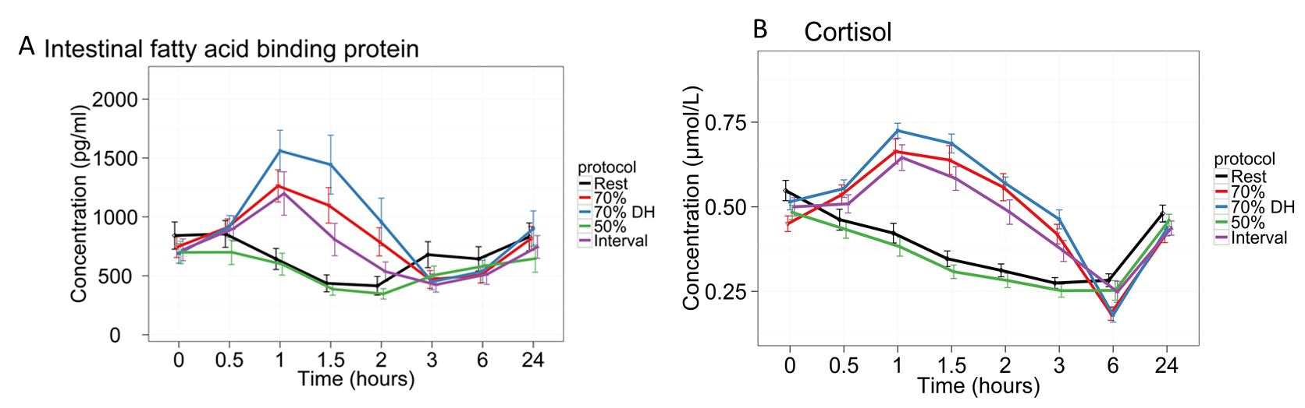

**Figure 4**. Effects of the rest protocol (black line) and exercise protocols on serum levels of intestinal Fatty Acid Binding Protein (A) and cortisol (B). The red and blue lines are showing the effects of 70% Wmax exercise in hydrated and dehydrated condition respectively and the green and purple lines are representing the exercise effects of 50% Wmax and intermittent 55/85% Wmax.

Exercise was performed between T0 andT1. At T1 the glutamine bolus was ingested (depicted by the black arrow). The effects are shown as mean with SD between the subjects.